**PowerCo Data Analysis**

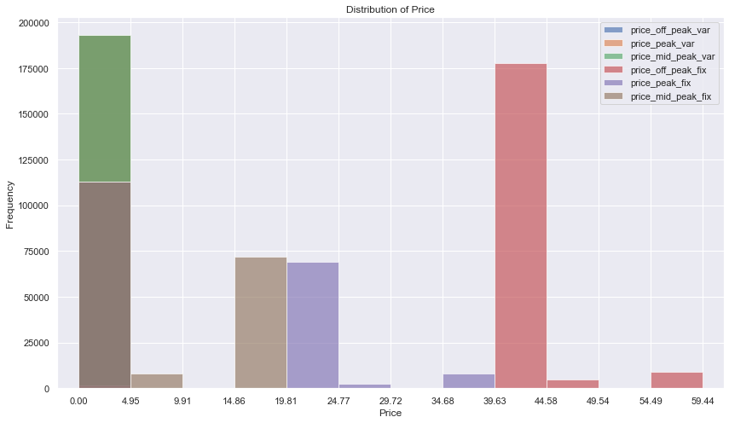

Upon observation of the distribution of price, price sensitivity does appear to be an influential factor in determining churn potential.